Board Game Ideas!
Theme suggestions: favourite activities (Lego, sports, pets, seasons, the sky is the limit!)

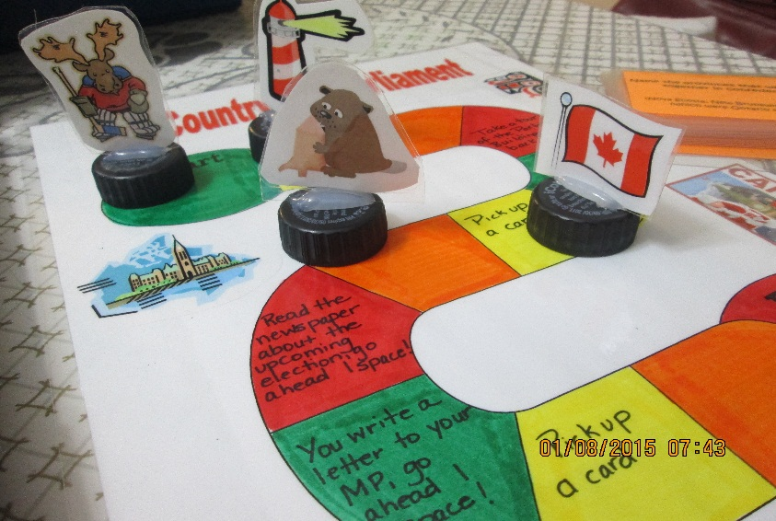
Game pieces glued to pop tops.

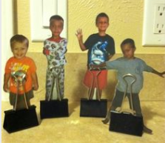
Draw and design characters and attach “bull-dog” clips to the bottom.

