bridges!

Choose an interesting bridge…any bridge in the world to research!
Find out the following;
- Name of bridge
- Location of bridge (city, country)
- Year of construction
- Materials used
- Structure or design (suspension, arches, wooden & covered, etc.)
- Length of bridge in metric
- 1 photo OR drawing of bridge
- Web site or name of book where you found your information
The information MUST be printed in your own words in sentences. The information will be displayed on the format (laptop foldable) shown below. All materials that are needed are provided. If all your information does not fit on the one piece of paper, then a second piece can be attached on the back. See example;
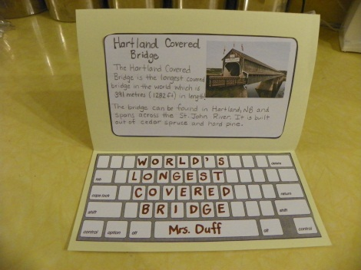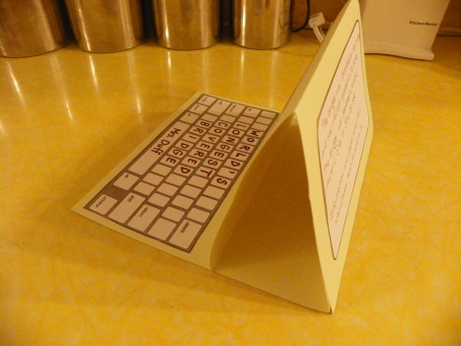
Useful web sites can be found at http://mrsduffsclassroom.weebly.com under Gr.3 Builders tab (bridges page). Books from the public library can be used as well. Projects will be scored with rubric below;
Bridge Laptop Rubric

 | 5: Strong Performance | 4 | 3: Appropriate Performance | 2 | 1: Experiencing Difficulty
Required information | All 8 items included. | 6-7 of the items included. | 4-5 of the items included. | 3 of the items included. | 2 or less of the items included.
Neatness and Creativity | Laptop book is exceptionally creative. Wonderful art work! Fantastic printing! | Laptop book is creative. Good art work.  Neat printing. | Laptop book is creative, but could use more effort. Somewhat neat printing. | Laptop book is rushed and more time was needed to be taken.  Printing is messy. | Laptop book is torn, missing items, messy and not to grade 3 standard.
Written information | Super description of your bridge. Written in your own words in complete sentences. | Great description of your bridge. Written in your own words in mostly complete sentences. | Good description of your bridge. Information is copied from book or web site. | Somewhat acceptable description of your bridge. Information is either copied or not in sentences. | No description of your bridge. Just words are included, no sentences.
Conventions  (spelling, punctuation, capitals) | Evidence of capitals, proper punctuation, spelling is correct.. WOW! | Most sentences capitals and has evidence of proper punctuation. Spelling is mostly correct. | Some sentences have capitals and evidence of proper punctuation. Spelling is somewhat correct. | Little evidence of capitals and proper punctuation, spelling is poor. | No evidence of capitals, proper punctuation and spelling is very poor.
Instructions Followed | Laptop ‘keyboard’ and ‘screen’ are cut neatly and glued on with title on ‘keyboard.' Photo or drawing of bridge included. | Laptop ‘keyboard’ and ‘screen’ are cut our neatly and glued on, but no title not on ‘keyboard.’ Photo or drawing of bridge included. | Laptop ‘keyboard’ and ‘screen’ are glued on, but no title on ‘keyboard,’ or cut out poorly. No photo or drawing of bridge included. | Laptop ‘keyboard’ or ‘screen’ are missing or cut out very poorly. No photo or drawing of bridge included. | Laptop items are missing. No photo or drawing of bridge.

