Editing
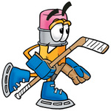
- Correct spelling
- Add punctuation
- Check for capital letters
- Grammar (does it sound right?)

