Prewriting
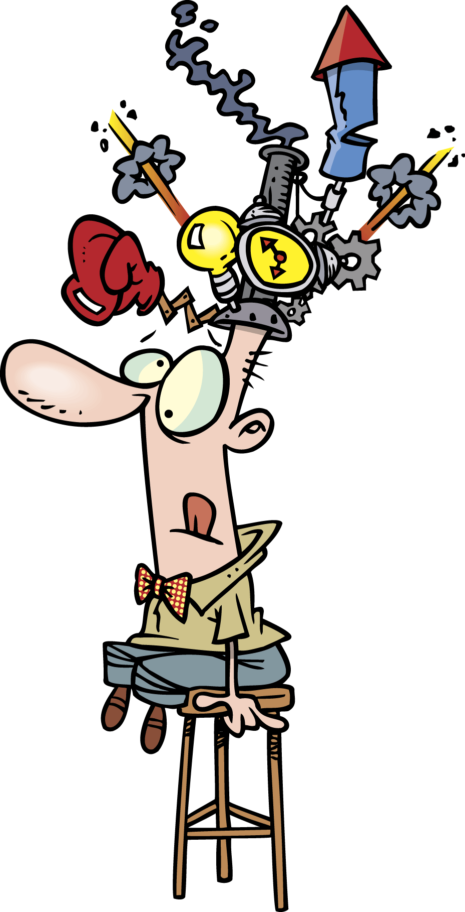
- Brainstorm ideas
- Sketch pictures
- Use webs, lists

