Revising
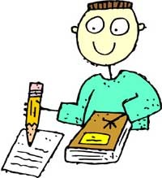
- Add details
- Change words
- Move things around

