The Writer’s Notebook
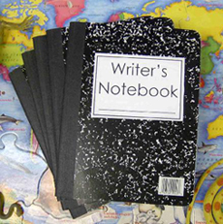
Paper bag
The students will be creating and building a Writer’s Notebook throughout the year to support them as authors. It would be wonderful if your child could choose a few items from home to place in the provided paper bag, which will be added to their notebook in class. Suggestions are; photos, magazine clippings, ticket stubs, sketches or drawings, comics clipped from the paper, etc. The book is their property and will be sent home in June. An option is to email me 1to3 photos to me at margo.duff@nbed.nb.ca and I can print them for them.

Index/recipe card: History of a Name
On the provided card, please share with your child the history of their name. (It can be all given names, or just their first name.) Why was it chosen? Are they named after someone? What is the meaning of their name? They can also add how they feel about their name, do they like it? Do they have a nick name at home? Why? This will be added to their Writer’s Notebooks as well.

Due date: Monday, September 16th, 2013
Email if you have any questions! Thanks! Mrs. Duff

The Writer’s Notebook
Paper bag
The students will be creating and building a Writer’s Notebook throughout the year to support them as authors. It would be wonderful if your child could choose a few items from home to place in the provided paper bag, which will be added to their notebook in class. Suggestions are; photos, magazine clippings, ticket stubs, sketches or drawings, comics clipped from the paper, etc. The book is their property and will be sent home in June. An option is to email me 1to3 photos to me at margo.duff@nbed.nb.ca and I can print them for them.

Index/recipe card: History of a Name
On the provided card, please share with your child the history of their name. (It can be all given names, or just their first name.) Why was it chosen? Are they named after someone? What is the meaning of their name? They can also add how they feel about their name, do they like it? Do they have a nick name at home? Why? This will be added to their Writer’s Notebooks as well.

Due date: Monday, September 16th, 2013
Email if you have any questions! Thanks! Mrs. Duff

