YUCK! LIST

Create your YUCK list on a new page in your notebook. List as many things that you find yucky! For example….do you like ketchup on your Kraft Dinner? What about toe nail clippings in your bed?

C:\Documents and Settings\margo.duff\Local Settings\Temporary Internet Files\Content.IE5\E6A6023F\MCj02322990000[1].wmf

Heart Map

On a page in your notebook, draw a heart that fills the page. List all of things that you keep close to your heart or that have had an impact on your life. You can add to this at any time. See the example provided.



“I’ve always wondered…”

Check out the web site, <http://wonderopolis.org>

List or sketch all of the things you have ever wondered about. Things you don’t understand or would be interested in learning about. For example…have you ever wondered about those huge head statues on Easter Island?

Special Memory

On a page in your notebook, write a short description or web a special childhood memory. What is one thing you will never forget?



Top Ten List

On a page in your notebook, create a top ten list about anything! Your top favourite foods, things, people, songs…whatever you would like. Remember, the number one is the top of your list.



Oh The Places You’ll Go… [](http://www.google.ca/imgres?um=1&hl=en&safe=active&sa=N&biw=1366&bih=626&tbm=isch&tbnid=xPNEaZUqDa4ZHM:&imgrefurl=http://www.fanpop.com/spots/dr-seuss/images/3389461/title/oh-places-youll-go-poster&docid=uV4B4r3oMBs0TM&imgurl=http://images2.fanpop.com/images/photos/3300000/Oh-The-Places-You-ll-Go-Poster-dr-seuss-3389461-721-519.jpg&w=721&h=519&ei=D-ShT_mgB6qE6AHH2eTeCA&zoom=1&iact=hc&vpx=1036&vpy=147&dur=1590&hovh=190&hovw=265&tx=122&ty=125&sig=107740828423553389839&page=1&tbnh=130&tbnw=181&start=0&ndsp=22&ved=1t:429,r:6,s:0,i:78)

After reading Dr. Seuss’ book, where do you want to go?

Awesome!

[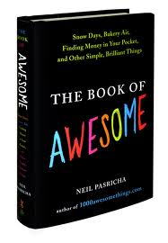](http://www.google.ca/imgres?um=1&hl=en&safe=active&biw=1366&bih=626&tbm=isch&tbnid=Ck9NnPHRtUgCSM:&imgrefurl=http://www.monniblog.com/2010/07/the-book-of-awesome-book-review/&docid=YmbkjaS4QMBjkM&imgurl=http://www.monniblog.com/wp-content/uploads/2010/07/book-of-awesome.jpg&w=452&h=653&ei=c-ShT_iDGOOK6QGCruDuCA&zoom=1&iact=hc&vpx=112&vpy=111&dur=500&hovh=270&hovw=187&tx=102&ty=138&sig=107740828423553389839&page=1&tbnh=137&tbnw=94&start=0&ndsp=20&ved=1t:429,r:0,s:0,i:64)

What do you find awesome?

Think of the little things in life that are awesome!

It was the best of times; it was the worst of times.”A Tale of Two Cities

[](http://www.google.ca/imgres?start=76&um=1&hl=en&safe=active&biw=1366&bih=626&tbm=isch&tbnid=nOAA94qUbZ56HM:&imgrefurl=http://worldatthewayside.com/2012/04/24/it-was-the-best-of-times-it-was-the-worst-of-times/&docid=ztQr1bNq-ViuMM&imgurl=http://28.media.tumblr.com/tumblr_lvzslsSjgn1r1402eo1_500.jpg&w=500&h=343&ei=EOWhT8SPMemy6QGQ6tXiCA&zoom=1&iact=hc&vpx=117&vpy=153&dur=281&hovh=186&hovw=271&tx=145&ty=107&sig=107740828423553389839&page=4&tbnh=131&tbnw=188&ndsp=25&ved=1t:429,r:0,s:76,i:5)

Copy this quote and create a ‘Best’ and ‘Worst’ list.

Word Up!

Pick a single word and write as much as you can! For example….camping or hair!

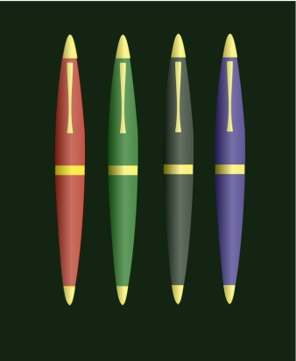

Ouch List

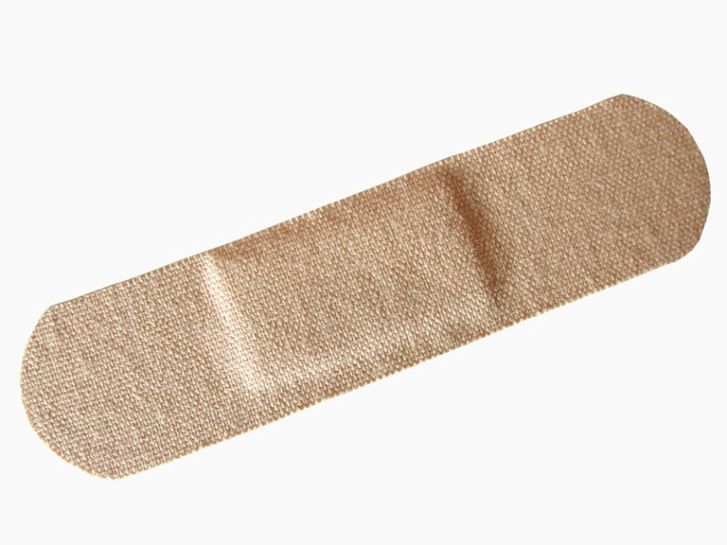

Create a list of all the times you have hurt yourself!

Expert List



Create a list of all the things you are good at!